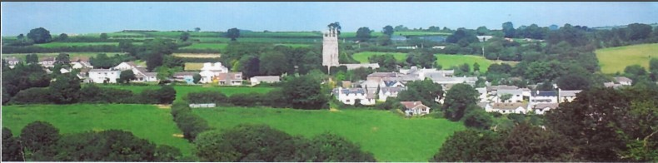

26th October 2024

Dear Councillor,

You are summoned to attend a meeting of North Hill Parish Council on Monday 4th November 2024 at 7.30pm in the Village Hall.

Please find attached the agenda for our meeting. We ask that if any member of the public has issues, they would like to raise that they contact the clerk prior to the meeting so that we can best manage them.

Please remember that the time allotted for Matters of Community Concern is not a forum to discuss what has taken place during this meeting and that any matter raised here would likely be added to the NEXT meeting agenda for discussion.

Yours faithfully,

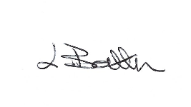

Lena Batten, Clerk to the Council

Members of the public are welcome to attend the meeting. However, we would like those attending to register prior to the meeting by emailing the Parish Clerk. Email: [northhillparishcouncil@btinternet.com](mailto:northhillparishcouncil@btinternet.com)

**AGENDA**

1. TO RECEIVE APOLOGIES:
2. CODE OF CONDUCT : a) TO RECEIVE DECLARATIONS b) TO GRANT DISPENSATIONS:

3. PUBLIC COMMENTS ON ITEMS ON THE AGENDA ONLY:

4. TO RECEIVE AND APPROVE THE MINUTES OF THE 8th OCTOBER 2024 FULL COUNCIL MEETING:

5. ANY MATTERS ARISING FROM PAST MINUTES NOT ON THE CURRENT AGENDA:

6. TO CONSIDER PLANNING APPLICATIONS RECEIVED FROM CORNWALL COUNCIL BY DATE OF THIS MEETING:

6.1 PA24/06142 – To note for information only - St Torneys Church Lynher Way North Hill Launceston Cornwall PL15 7PQ - Proposal Listed Building Consent for reinstatement of lime plaster on the internal walls of the south porch - approved.

6.2 PA24/06655 – To note for information only – Rayford Lodge, Bathpool Launceston Cornwall PL15 7NW - Proposal Re-roofing, adding two dormers to the North West elevation, a Juliet balcony/window to the North East elevations and converting the garage to a study – approved.

6.3 PA24/06180 – To note for information only - Tolcarne, Tolcarne Road North Hill Launceston Cornwall PL15 7QX - Proposal Listed building consent to recover north west roof pitch and adjacent lean to roof. Vertically slate chimney – approved.

6.4 PA24/05961 – Listed for further discussion following further information being received.

7. ANY APPLICATIONS RECEIVED BEFORE THE DATE OF THIS MEETING: none.

8. TO REVIEW CORRESPONDENCE AND TO AGREED RESPONSES REQUIRED:

8.1 To resolve the request to consider options regarding anti social behaviour in the sports field.

8.2 To discuss / resolve the use of the top car park for residents of North Hill Parish parking.

8.3 To note a thankyou from Mr Ian Scott for the letter sent from North Hill Parish Council to say

thankyou for the donation of hardcore.

8.4 To consider attendance at a Planning Policy update Teams meeting to be held on the 7th November.

8.5 To note for confirmation a padlock has now been fitted to the cemetery gate.

8.6 To accept and agree a response to the information received on telecommunication resilience.

8.7 To agree 63p per hour NALC annual increase for clerk plus any additional increment considered.

8.8 To consider / resolve writing to North Hill Village Hall to update them on the car park following initial

visit to the solicitor in order to ensure transparency.

8.9 To confirm North Hill Parish Council are in agreement with the clerk continuing to liaise with the

solicitor on their behalf.

8.10 To resolve whether to agree to a site audit following WCGA compliance coming into force.

9. TO REVIEW DETAILS FOR NORTH HILL PARISH COUNCIL CEMETERY FOLLOWING THE MEETING HELD ON THE 21st OCTOBER:

10. APPROVAL OF THE LIST OF PAYMENTS / RECEIPTS FOR OCTOBER 2024 & TO RECEIVE OCTOBER 2024 BANK STATEMENT:

10.1 AUTHORISATION OF EXPENSES INCLUDING SALARY:

i) £18.00 (PAYE G. Pollard payroll October, dd)

ii) £713.96 (Salary inclusive of tax, Lena Batten, October)

iii) £43.64 (room rent)

iv) £8.00 (bank charges)

v) £950.00 (footpath cutting 2024)

vi) £252.00 (BDO external audit)

vii) £135.00 (D. B. Daniells, maintenance to old track)

viii) £23.59 (Lena Batten, purchase of padlock and chain for cemetery)

ix) £296.93 (Zip wire, Ruby’s Car Sales)

x) £20.00 (Lena Batten, purchase of Wreath).

10.2 RECEIPTS: i) £186.95 (VAT reimbursement).

10..3 To receive bank statement:

Bank Statement as of 28th October 2024 £22,231.56.

10.4 To note conclusion of the annual external audit.

11. To set the budget for the next financial year 2025-2026 and agree the precept amount for submission:

11.1 To review / update North Hill’s Risk Assessment and Management Financial Regulations.

11.2 To review / update North Hill’s Financial Standing Orders.

11.3 To review / update North Hill’s Asset register.

12. To agree the advert for grant applications to be distributed with applications being heard at the December meeting and review grant policy:

13. To note for information a reduction in interest rates for HSBC account holders.

14. TO REVIEW MONTHLY BUDGET RECONCILIATIONS:

14.1 Budget Sheet Attached.

15. TO REVIEW MONTHLY RAG: (Red, Amber, Green)

15.1 RAG Sheet attached.

16. REPORT FROM CORNWALL COUNCIL WARD MEMBER COUNCILLOR PARSONS:

17. ITEMS FOR INCLUSION AT THE NEXT MEETING:

18. DATE & TIME OF NEXT MEETING:

19. CLOSE OF BUSINESS: